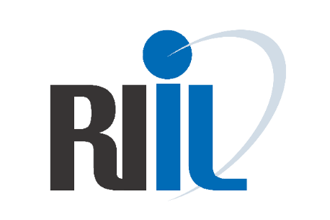
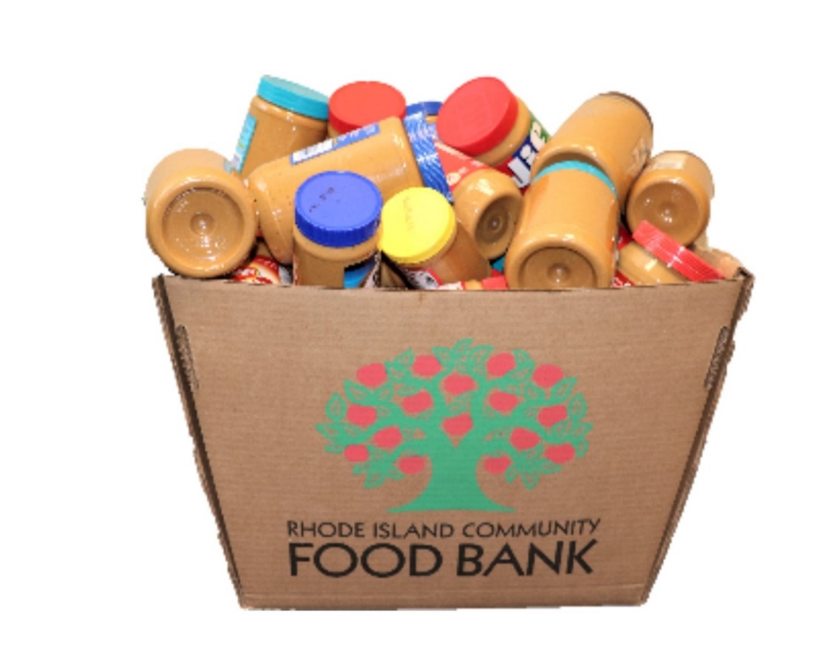
PEANUT BUTTER JARS MAY BE DROPPED OFF:
(insert location of your school’s peanut butter collection)

Over the last 10 years, high schools across the state have collected more than 10 tons of peanut butter for the R.I. Community Food Bank.
Join us in the fight against hunger!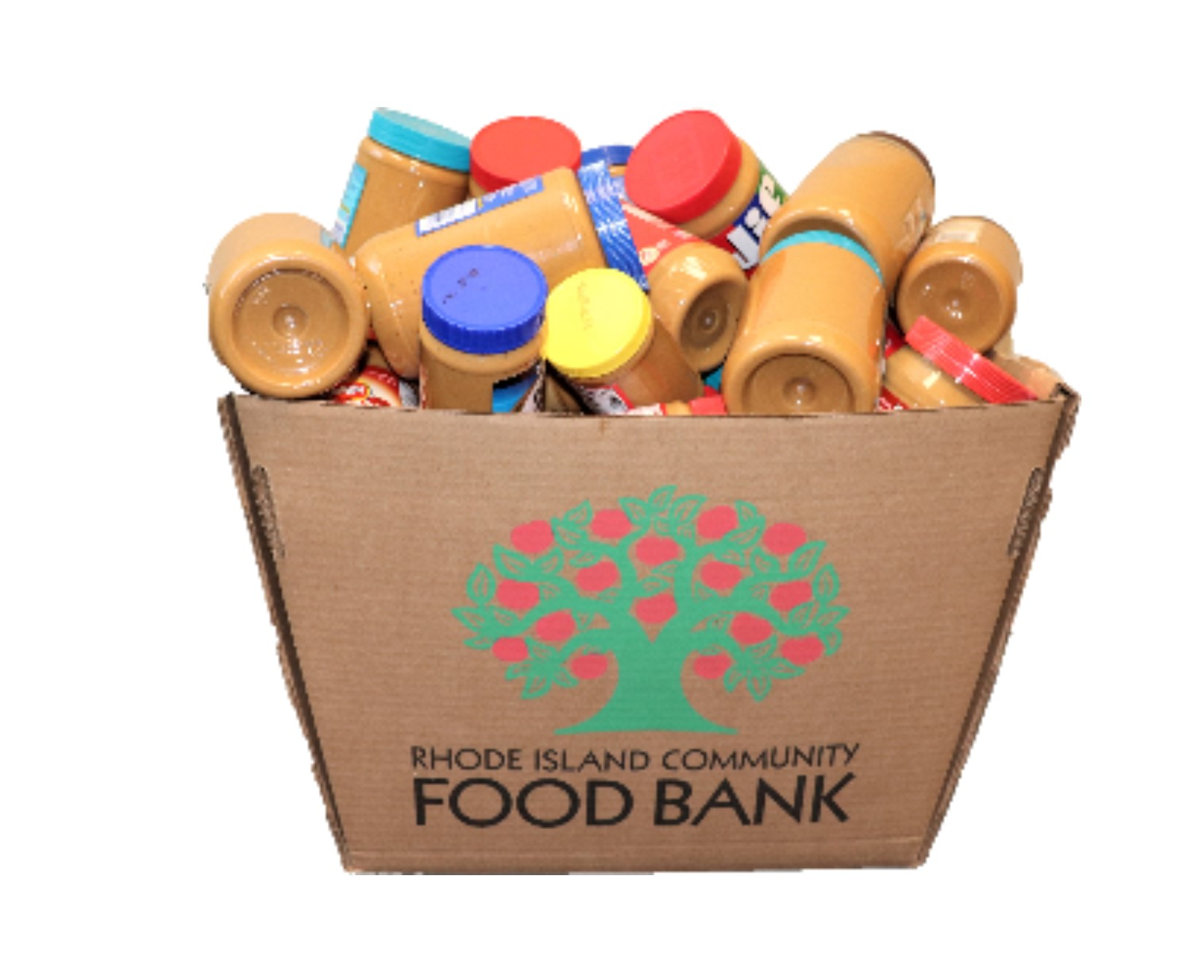and help beat hunger in R.I.!

SPREAD THE WORD!
(insert your school) IS TAKING PART IN THE:
R.I. Interscholastic League
11th annual
Peanut Butter Express Challenge

Collecting jars for the month of April!
Did you know?
1 in every 6 of RI’s children
will go to bed hungry
each night

